1. Make sure that the software is connected to the machine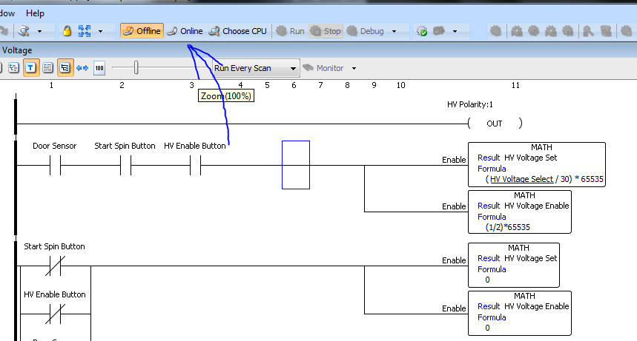
2. Open Data View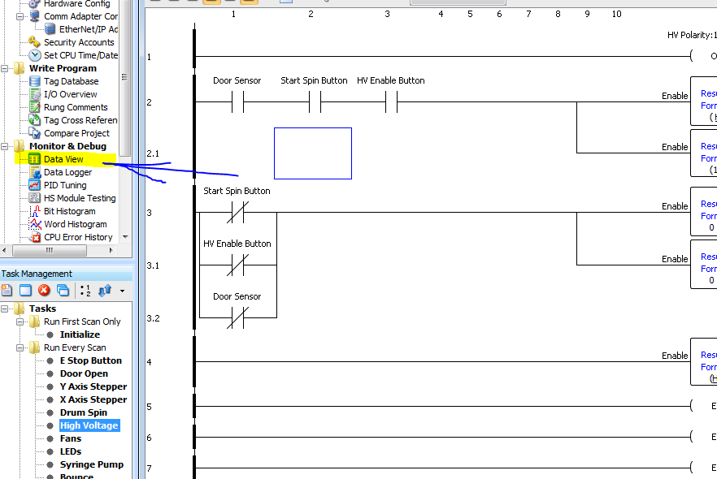
3. Input data into the display, press play in the software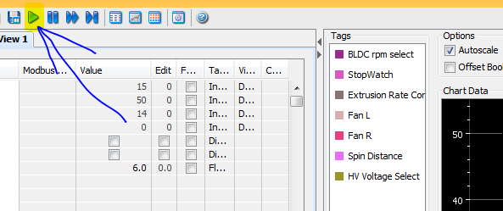
4. Once spinning is done, press pause and click export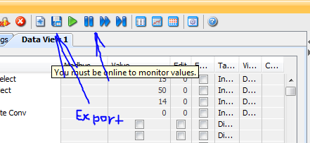

# For each new set of data, repeat steps 3 and 4’